1 HMS Microfluidics/Microfabrication Core
2 DF/HCC Rodent Histopathology
3 DF/HCC Mouse Engineering Core
4 Gnotobiotic Core Facility
5 Genomic Modification Facility
6 Mouse Behavior Core
7 Research Computing Core
8 Research Data Management Services -HMS Research Computing
9 Rigor, Reproducibility, and Responsibility (R3) at HMS
10 Electronic Lab Notebooks and Research Imaging Solutions
11 Bauer Sequencing Core
12 BPF NGS Genomics Core Facility
13 Quantitative Biomedical Research Center (qBRC)
14 Center for Computational Biomedicine (CCB)
15 HCBC- Harvard Chan Bioinformatics Core
16 HCBC- Harvard Chan Bioinformatics Core
17 Harvard Chan Microbiome Analysis Core
18 Single Cell Core
19 SEAS Molecular and Cellular Biology Core (MCB)
20 Nascent Transcriptomics Core
21 SEAS 3D Printing Core
22 Research Instrumentation Core
23 Molecular Electron Microscopy Suite
24 Harvard Cryo-EM Center for Structural Biology
25 Bio-NMR
26 Center for Macromolecular Interactions (CMI)
27 Taplin Mass Spectrometry Facility
28 Analytical Chemistry Core
29 Drug Discovery Sciences Core
30 ICCB-Longwood Screening Facility
31 Drosophila Research & Screening Center-Biomedical Technology Research Resource (DRSC-BTRR)
32 Immunology Flow Cytometry Core facility
33 HSCI iPS Core
34 Bauer Flow Cytometry Core
35 Connectomics Core
36 Conventional Electron Microscopy Core
37 MicRoN- Microscopy Resource on the North Quad

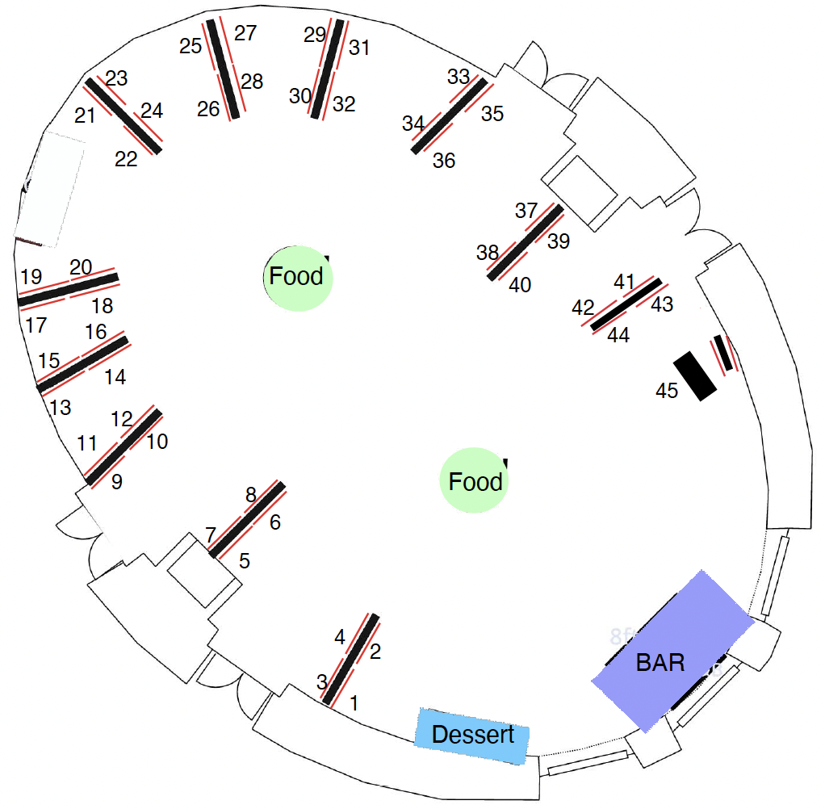

38 Center for Nanoscale Systems - SEC Imaging Core
39 NIF Imaging and Advanced Tissue Processing Core
40 HCBI- Harvard Center for Biological Imaging
41 HCBI- Harvard Center for Biological Imaging - Satellite Cores
42 Center for Nanoscale Systems
43 Center for Nanoscale Systems (CNS) Materials Characterization Core
44 FAS Chemistry and Chemical Biology X-ray Lab
45 DF/HCC PATHFINDER

